Test Driven Development Plan

Definition

“Test-driven development” refers to a style of programming in which three activities are tightly interwoven: coding, testing (in the form of writing unit tests) and design (in the form of refactoring).

It can be succinctly described by the following set of rules:

* write a “single” unit test describing an aspect of the program
* run the test, which should fail because the program lacks that feature
* write “just enough” code, the simplest possible, to make the test pass
* “refactor” the code until it conforms to the simplicity criteria
* repeat, “accumulating” unit tests over time

Using the definition of Unit testing [here](https://www.xenonstack.com/insights/what-is-unit-testing/#:~:text=Unit%20testing%20is%20a%20type,and%20produces%20a%20single%20output.)

Junit has been used to perform the following Unit tests in netbeans.

Unit Tests:

1. Draw Game Board
2. Display markers from coordinates
3. Accept 2 Human Opponents
4. Accept 1 Human Opponents
5. Accept 0 Human Opponents

[UNIT TEST 1 ]Draw Game Board

The program will draw a blank game board , working our way to successfully being able to drawn a game board of any size.

Goal :

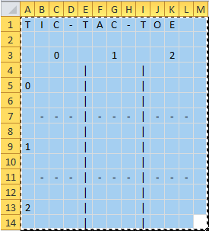

Pseudocode

For a given number of row

For given number of columns

print cell

if col not last print vert line

if row not last print horizontal line

initial Test outcome :

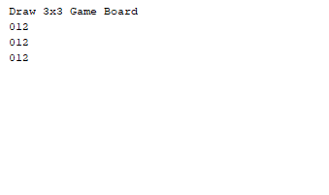

Test 2

Draw a 3x3 Game Board: Draws 3 columns for 3 rows , each cell in a row numbered 1 to 3

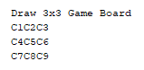

Draws 3 columns for 3 rows , for each cell and order value is called from a list of values

Test 3

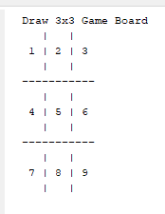

Draws 3 columns for 3 rows , for each cell an order value is called from a list of values , also some added templates for the game board

[UNIT TEST 2] Display markers from coordinates

The Program will draw markers in the correct position on the board

[UNIT TEST 3] Accept 2 Human Opponents

[UNIT TEST 4] Accept 1 Human Opponents

[UNIT TEST 5] Accept 0 Human Opponents